PROBLEMS IN DATA ANALYSIS | OSALUSI CHRISTOPHER (27689198)

(1)

TITLE: AN EXPERIMENTAL DESIGN INVESTIGATING THE EFFECT OF LIGHT INTENSITIES ON THE RATE OF PHOTOSYNTHESIS IN A LETTUCE PLANT

AIM & OBJECTIVE :  The aim of this study is to determine the effect of light intensity and temperature on crop growth and development. Furthermore, we determine a suitable light range at different temperatures for producing the lettuce Lactuca sativa L. Artificial climate chamber experiments were conducted at five light intensities (100,200,350, 500 and 600µmol.m-2 s-1) as well as at low (10˚ C / 15˚ C) and high (25˚ C/30˚ C ) temperatures.

(ii)

|  |  |  |
| --- | --- | --- |
| leaf area | temperature | light intensity |
| 202 | 30 | 100 |
| 391 | 10 | 200 |
| 391 | 30 | 350 |
| 202 | 10 | 500 |
| 296.5 | 20 | 600 |

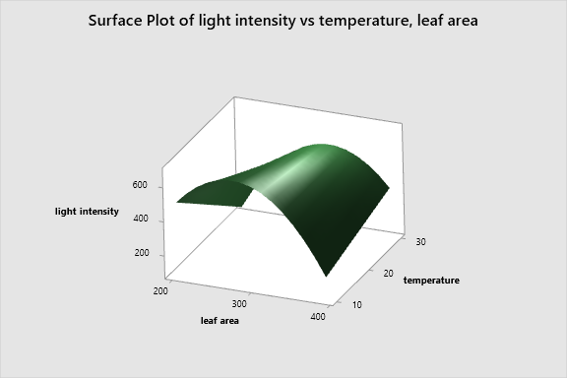

**Regression Equation in Uncoded Units**

|  |  |  |
| --- | --- | --- |
| light intensity | = | -1449 + 17.71 leaf area - 49.39 temperature - 0.03499 leaf area*leaf area + 0.1455 leaf area*temperature |

**Coded Coefficients**

|  |  |  |  |  |  |
| --- | --- | --- | --- | --- | --- |
| **Term** | **Coef** | **SE Coef** | **T-Value** | **P-Value** | **VIF** |
| Constant | 600.0 | * | * | * |  |
| leaf area | -12.50 | * | * | * | 1.00 |
| temperature | -62.50 | * | * | * | 1.00 |
| leaf area*leaf area | -312.5 | * | * | * | 1.00 |
| leaf area*temperature | 137.5 | * | * | * | 1.00 |

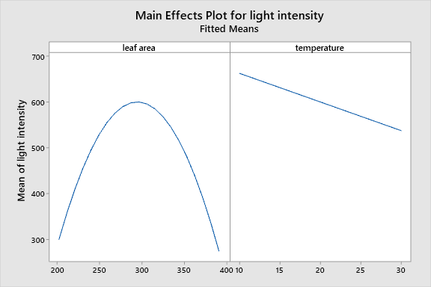

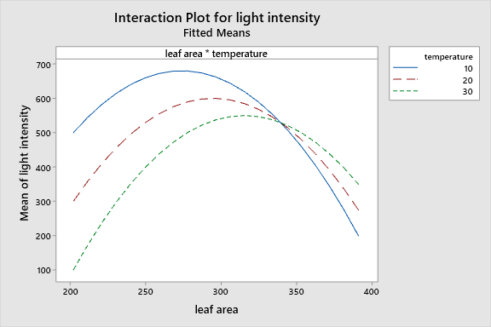

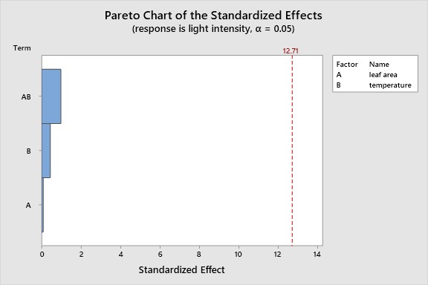

PROBLEMS IN DATA ANALYSIS | OSALUSI CHRISTOPHER (27689198)

2a

**Principal Component Analysis: Pregnancies, Glucose mg/dL, BloodPressure mmHg, SkinThickness um, Insulin mIU/L**

**Eigenanalysis of the Correlation Matrix**

|  |  |  |  |  |  |
| --- | --- | --- | --- | --- | --- |
| Eigenvalue | 1.7484 | 1.2385 | 0.9089 | 0.7217 | 0.3826 |
| Proportion | 0.350 | 0.248 | 0.182 | 0.144 | 0.077 |
| Cumulative | 0.350 | 0.597 | 0.779 | 0.923 | 1.000 |

**Eigenvectors**

|  |  |  |  |  |  |
| --- | --- | --- | --- | --- | --- |
| **Variable** | **PC1** | **PC2** | **PC3** | **PC4** | **PC5** |
| Pregnancies | 0.095 | -0.686 | -0.435 | 0.550 | -0.169 |
| Glucose mg/dL | 0.523 | -0.405 | -0.119 | -0.532 | 0.515 |
| BloodPressure mmHg | 0.313 | -0.314 | 0.859 | 0.177 | -0.185 |
| SkinThickness um | 0.488 | 0.450 | -0.036 | 0.589 | 0.459 |
| Insulin mIU/L | 0.617 | 0.252 | -0.240 | -0.190 | -0.680 |

**Comments**

From the eigenvalues obtained, the proportion value of PC1 and PC2 are the most significant PCs because the make 59.7% of the PCs. Insulin, Glucose and SkinThickness are the most important variable of PC1 while Pregnancies, SkinThickness and Glucose are the most important variable of PC2.

(2b)

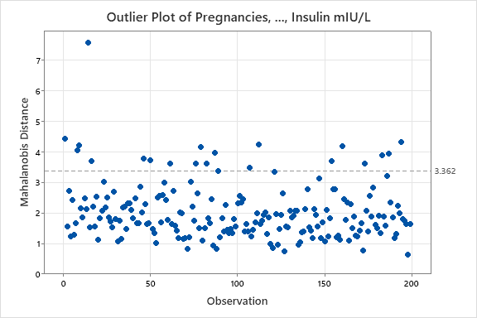

**Comments**

There are presence of outlier because some data crosses the dashboard at 3.362

(2c)

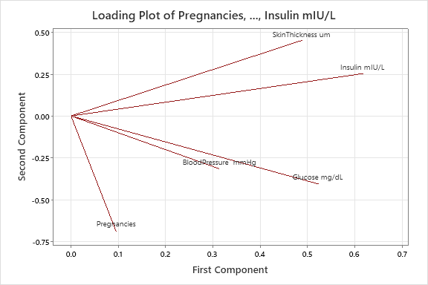

**Comments**

In this loading plot, The highest principal component (PC1) are the variables of Insulin, Glucose and SkinThickness. The highest principal component (PC2) are the variables of Pregnancies and Skin Thickness and Glucose.

(2d)

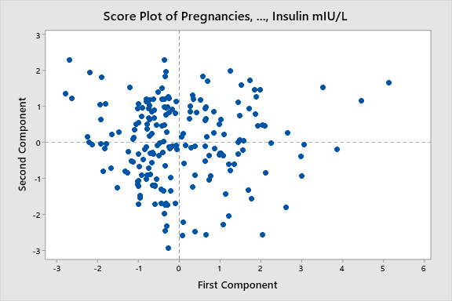

**Comments**

The score plots indicate a close relationship with the variables, and the variables are clustered to each other.

(2e)

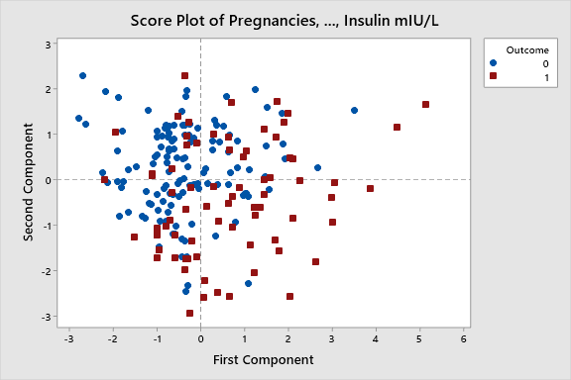

**Comments**

The PC1 are mostly influenced by patient that are prone to diabetes while PC2 is mostly influenced by patient that are not prone to diabetes. The variable that mostly influenced PC1 are glucose, insulin and Skin thickness showing that these variables influence diabetic patients. Likewise, pregnancies, glucose and skin thickness influence non-diabetic patients.

(2f)

**Discriminant Analysis: Outcome versus Pregnancies, Glucose mg/dL, BloodPressure mmHg, SkinThickness um, Insulin mIU/L**

Linear Method for Response: Outcome

Predictors: Pregnancies, Glucose mg/dL, BloodPressure  mmHg, SkinThickness um, Insulin mIU/L

**Groups**

|  |  |  |
| --- | --- | --- |
| Group | 0 | 1 |
| Count | 125 | 74 |

**Summary of Classification**

|  |  |  |
| --- | --- | --- |
|  | **True Group** | |
| **Put into Group** | **0** | **1** |
| 0 | 94 | 27 |
| 1 | 31 | 47 |
| Total N | 125 | 74 |
| N correct | 94 | 47 |
| Proportion | 0.752 | 0.635 |

**Correct Classifications**

|  |  |  |
| --- | --- | --- |
| **N** | **Correct** | **Proportion** |
| 199 | 141 | 0.709 |

**Summary of Classification with Cross-validation**

|  |  |  |
| --- | --- | --- |
|  | **True Group** | |
| **Put into Group** | **0** | **1** |
| 0 | 93 | 27 |
| 1 | 32 | 47 |
| Total N | 125 | 74 |
| N correct | 93 | 47 |
| Proportion | 0.744 | 0.635 |

**Correct Classifications with Cross-validation**

|  |  |  |
| --- | --- | --- |
| **N** | **Correct** | **Proportion** |
| 199 | 140 | 0.704 |

**Squared Distance Between Groups**

|  |  |  |
| --- | --- | --- |
|  | **0** | **1** |
| 0 | 0.00000 | 1.16902 |
| 1 | 1.16902 | 0.00000 |

**Linear Discriminant Function for Groups**

|  |  |  |
| --- | --- | --- |
|  | **0** | **1** |
| Constant | -10.903 | -15.168 |
| Pregnancies | 0.158 | 0.292 |
| Glucose mg/dL | 0.109 | 0.138 |
| Blood Pressure  mmHg | 0.129 | 0.127 |
| SkinThickness um | 0.090 | 0.099 |
| Insulin mIU/L | -0.013 | -0.012 |

**Comments**

On the LDA outcome, the group 0 count is 125 while the 1 count is 74 and the total measure of group 0 is on 75.2% while 1 is on 63.5% the class shows that in group 0, 94 was correctly placed while in 27 was misclassified whereas in group 1, 47 were right while 31 was misclassified into group 0.

(g)

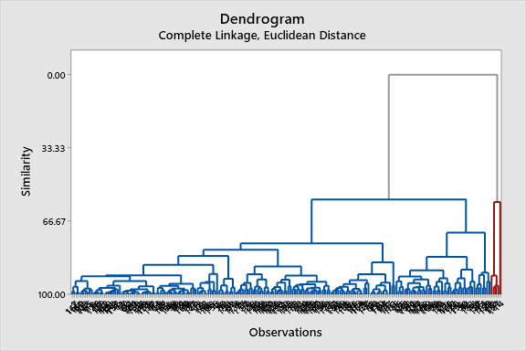

**Comments**

On the HCA, Glucose, Blood pressure and Insulin are of heavy weight in Cluster 1, while Insulin, Glucose and Blood Pressure are of heavy weight in Cluster 2, the distance between Cluster 2 is of large value than Cluster 1.

(h)

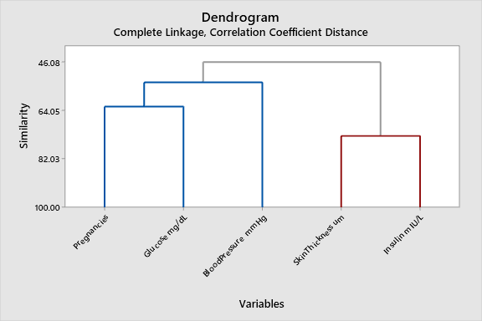

**Comments**

The tree diagram indicate that Pregnancies and Glucose are strongly correlated with each other, while the Skin Thickness and Insulin are strongly correlated.

(i)

The diabetes data set gives an overview of all data set analyze which are Pregnancies, Glucose, Insulin, Skin Thickness and

REFERENCES

*Marshall Cavendish. (2004).*Encyclopedia of Life Sciences*(2nd ed., Vol. 10). Tarrytown, NY: Marshall Cavendish*

*Photosynthesis. (2015). In*The Columbia Encyclopedia*(6th ed.). New York, NY: The Columbia University Press.*

Zhou, J., Li, P., Wang, J. and Fu, W. (2019). Growth, Photosynthesis, and Nutrient Uptake at Different Light Intensities and Temperatures in Lettuce. *HortScience*, 54(11), pp.1925–1933. doi:https://doi.org/10.21273/hortsci14161-19.